1. **Given the provide data, what are three conclusion we can draw about Kickstarter campaign?**
   1. 53% (2,185 out of 4,114) of Kickstarter campaigns have successfully made the funding process with positive outcome.
   2. Music (Rock), Theater (Plays) and film&video (documentary) are the top three categories and (sub-categories) with the highest success rate (~> 50%) as well as these categories cover 64% of total campaigns.
   3. Lower $ goal have higher percentage of success rate than higher $ goal.
2. **What are some limitations of this dataset?**
   1. The dataset doesn’t clarify if the amount in “goal” and “pledged” columns are in US dollar. If not, we have not considered currency conversion and the analysis may not be valid.
   2. The dataset doesn’t have full year information for 2019 and 2017 looking at the creation date column.
3. **What are some other possible tables and/or graphs that we could create?**
   1. Pie graph indicate 74% of total 4,114 campaigns are from US, 15% from GB and 11% from the rest of countries.

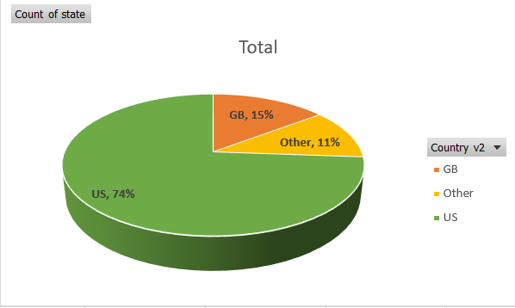

* 1. Looking at all successful categories, “Technology” has the highest average donation of $124 per backers.
* 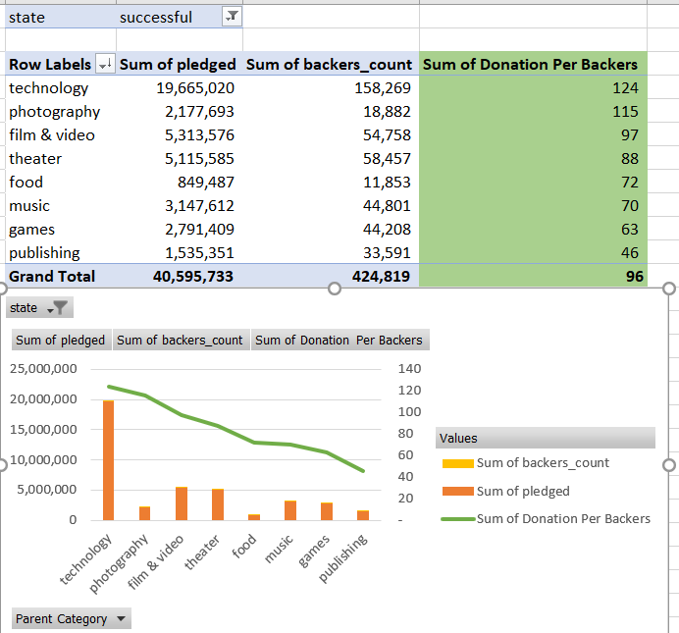
  1. Looking at all successful categories, there is no significant relationship between the campaign period and donation amount. (see the graph below)

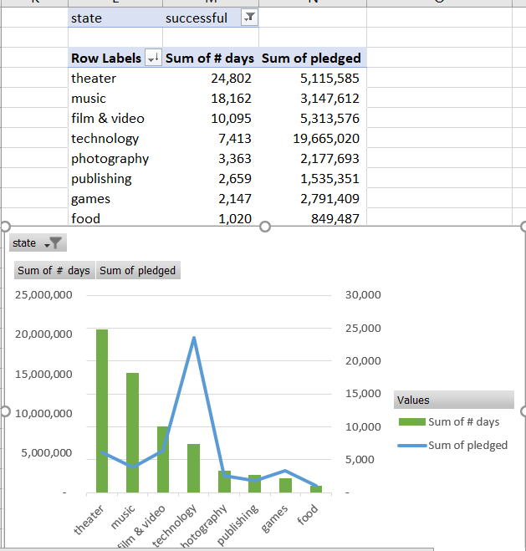

* 1. Looking at all state categories, “successful” category has the highest disparity campaign period and also highest pledged.

